**TASK-01**

**EXPLANATION:**

Write a program to print following pattern.

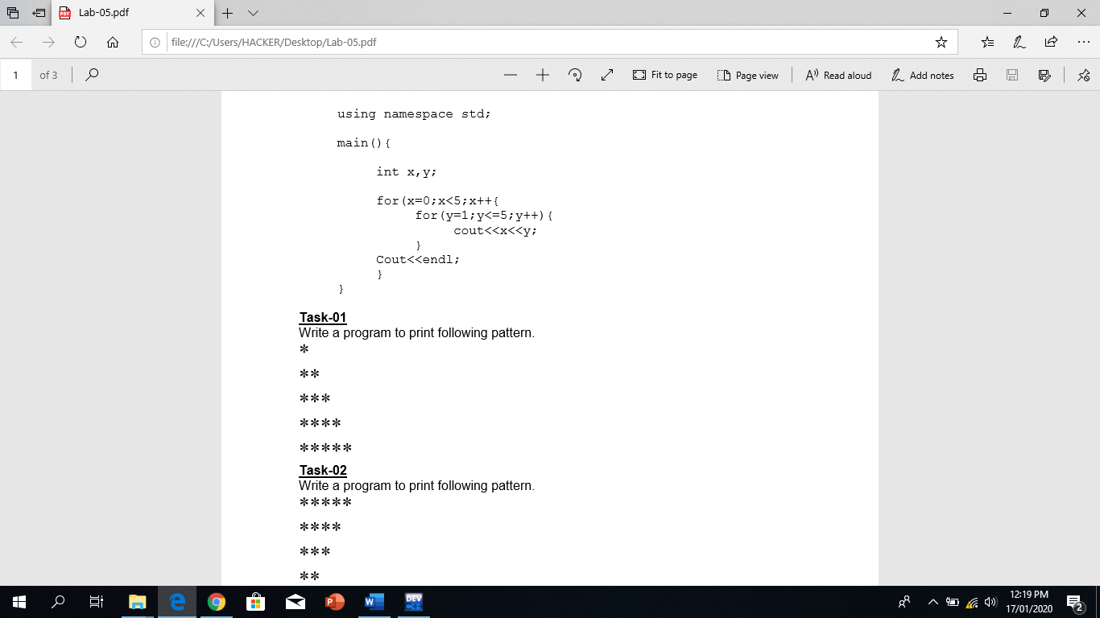

**INPUT:**

#include <iostream>

#include "abdullah"

#include <string>

using namespace std ;

int main ()

{

bool flag = true ;

while ( flag )

{

int length ;

string line = "Please enter the base or height of (R.H.S) right triangle : " ;

cout << line ;

while ( ! ( cin >> length ) )

{

cin_clear ( line ) ;

}

system("cls") ;

for ( int i = 1 ; i <= length ; i++ )

{

for ( int j = 1 ; j <= i ; j++ )

{

cout << "*" ;

}

cout << endl ;

}

flag = continuationLoop () ;

}

}

**OUTPUT:**

